17. Perform Edge Detection Using Sobel Matrix Along X-Axis
Aim
To perform edge detection on an image using the Sobel operator along the X-axis in Python with OpenCV.
Procedure
- Import the OpenCV library.
- Read the input image.
- Convert the image to grayscale.
- Apply the Sobel operator along the X-axis.
- Convert the output to an absolute scale for proper display.
- Display the original image and the Sobel X edge-detected image.
- Close all windows after a key is pressed.

Python Code
Python
Run
import cv2

# Read the image
image = cv2.imread("image.jpg")

# Convert to grayscale
gray = cv2.cvtColor(image, cv2.COLOR_BGR2GRAY)

# Apply Sobel edge detection along X-axis
sobel_x = cv2.Sobel(gray, cv2.CV_64F, 1, 0, ksize=3)

# Convert to absolute values
sobel_x = cv2.convertScaleAbs(sobel_x)

# Display images
cv2.imshow("Original Image", image)
cv2.imshow("Sobel X Edge Detection", sobel_x)

# Wait for a key press
cv2.waitKey(0)
cv2.destroyAllWindows()
Output
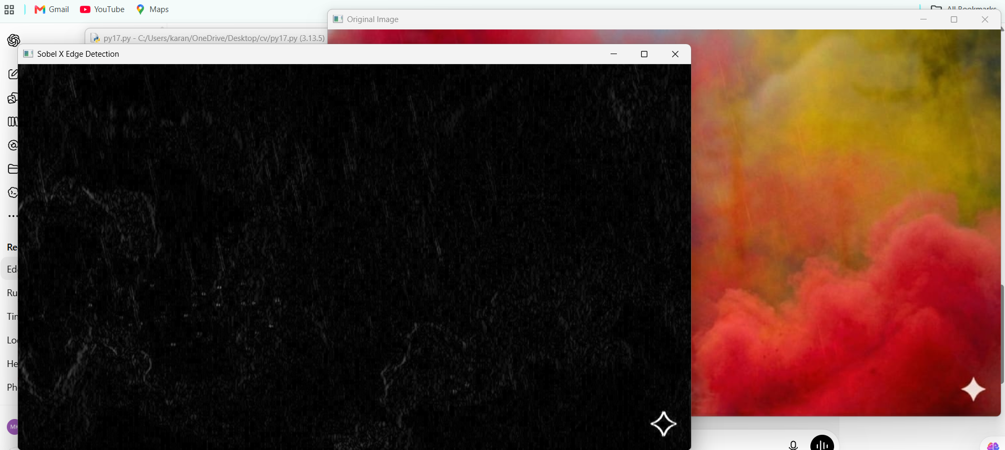
Result
The edges of the given image were successfully detected along the X-axis using the Sobel Matrix in Python with OpenCV.

